**Analysis Specification**

**On**

**Football League Management System**



**Name: Keeyoshi Pyakurel**

**NCC ID: 00175008**

**Batch: 22 ‘D’**

**Email: Keeyoshi99@gmail.com**

**Level 5 Diploma in Computing**

**Softwarica College of IT and E-Commerce**

**Submitted to: Mr. Niman Maharjan**

Table of Contents

Chapter 2. Analysis 1

2.1. Introduction to Analysis 1

2.2. Feasibility Study 3

2.3. Requirement Analysis 4

i. Functional Requirements 4

ii. Non-Functional Requirements 7

iii. MoSCoW Prioritization 9

iv. System Requirement Specification 12

2.4. Use case 12

2.5. Initial Class Diagram (NLA) 14

2.6. References 18

**Table of Figure**

Figure 1 Functional analysis 6

Figure 2 Non-functional Requirement 7

Figure 3 MoSCoW Prioritization 9

Figure 4 Use Case Diagram 13

Figure 5 Initial Class Diagram 17

# Chapter 2. Analysis

# Introduction to Analysis

After completing the proposal the next phase is analyzing the requirement. In analysis phase we understand the project needs and processing needs. We managed all the requirement and sort what are importance. Analysis phase is very essential as it establish the documentation for the final project. Without proper analysis the system won’t be completed as it will always missed what the user really wants and what the user needs.

We need to perform analysis phase to analyze the requirement for the final product and approved the requirement on basis of if it really needed or not. It helps to understand the system, it requirement/features, how the system works, etc. There are different types of analysis they are PEST analysis, SWOT analysis, CATWOE analysis, ethical analysis etc**.**

**PEST analysis:** PEST analysis is used to recognize the Political, Economic, Social and Technological factors that can affect the project and its planning process. (Nishadha Silva, 2016). PEST analysis is used when studying about different factors which is required to take consider. It aids to realize more about market growing or failure, potential etc.

**SWOT analysis:** SWOT analysis is used to understand and recognize the Strength, Weakness, Opportunity and Threats of the system. It help to understand and recognize and concentration on strengths, reduce threats and take the highest potential benefit of opportunities that are available

**CATWOE analysis:** CATWOE analysis is a method used for understanding a stakeholder perspective and the consequence that it will have on the system. (Business Change Academy, 2017) It stands for Customer (C), Actor (A), Transformation (T), Worldview (W), Owner (O) and Environment (E).

**Ethical analysis:** Ethical analysis is a method to figuring out the correct morale decision in particular situation according to ethical code and morale. It help to figure out which options are both effective and moral.(Fraser Sherman, 2019)

Analysis phase help us to understand the system and its requirement. We can get information about what the system want by doing survey, questionnaires, interview etc. after completing analysis we get information about what the system should do. It helps in understanding of complex structure it really importance to analyze the system completely before continuing to the next stage. It help in making decision and provide various option to understand the final outcome

* **Benefits of system analysis**

Some benefits of system analysis are as follows:

* It helps to reduce cost
* To helps to make the system more flexible, efficient, reliable etc.
* It helps to identify the risk, prevention and how to solve it
* Better management, controls
* Better quality
* Help in planning of the resources for development

The above are the some benefits of analysis. However analysis provide more benefits to the project but too much analysis can also cause problem. Too much analysis which can be time consuming and expensive. So finding the right balance is key for successful analysis.

Analysis is the beginning stage of waterfall model which help to accomplish a successful system implementation

# Feasibility Study

A feasibility analysis study is used to measure the ability and likelihood to complete the project successfully. It is performed by enterprise when examination whether the given project is possible in different conditions like whether if the enterprise has enough money or if the project will be sold or even if there are enough human resources. There are many types of feasibility study they are as follow:

* **Technical feasibility:** Technical feasibility check whether the enterprise have the technological resources to undertake the project? Does the methods and measures helpful to the project success. The technical resources for finishing my project are Laptop, internet, XAMPP etc.
* **Schedule feasibility:** Schedule feasibility check if the organization have the time resources to undertake the project? Also to check if the project can be accomplished in the given available time.
* **Economic feasibility:** Economic feasibility is also known as cost/benefit analysis. It check it helps in identifying profit against investment expected form the project.
* **Cultural feasibility:** Cultural feasibility study is done to evaluate what the impact of the project on the both local and general culture.
* **Legal/Ethical feasibility:** Legal/Ethical feasibility is a test to determine to check if the given project is ethical, or even legal. The System must not be illegal and affect user morale while using the system.
* **Operational feasibility:** Operational feasibility is a test to check how well the developer can and will be able to solve the problem and take the advantage of opportunities.

# Requirement Analysis

Requirement analysis is the process to determine what the user except from the system. This includes features/requirement which must be quantifiable, applicable/related and detailed.

## Functional Requirements

Functional requirement are those that specific what the system should do. It describe a certain behavior of the function when a particular condition are met. It describe what the system should do the functional requirement describe the behavior of the system as it relates to the system function.

Some of the functional requirement for this project are as follow:

|  |  |  |  |  |
| --- | --- | --- | --- | --- |
| **ID** | **Title** | **Description** | **Rational** | **Dependency** |
| FR1 | User Registration | User should be able to register for login | To be able create profile and login | N/A |
| FR2 | User login | User login helps for access to system, profile etc. | To access the system, profile and security measure | FR1 |
| FR3 | Edit/Delete User profile | User should be able to edit/delete their profile. | To manage profile, update profile or delete profile. | FR2 |
| FR4 | Admin Login | Admin Login for Updating Sites | To be able to update, add, delete from or to the site | N/A |
| FR5 | Create League | Admin can create New League | To be able to create new league from the system | FR4 |
| FR6 | Create Team | Admin be able to add new team to league | To be able to add teams to the league | FR4 |
| FR7 | Create Player or Coach | Admin can add Player and Coach to the team | To be able to assign team player and coach for particular tam | FR4 |
| FR8 | Edit League, Team, Player, Coach | Admin can edit information about following | To be able to edit or remove league, team, player and coach | FR4 |
| FR9 | View Player and Coach Details | User can be able to view details of Plyer and Coach | To allowed access to see information about player and Coach | FR2 |
| FR10 | View Team and League details | User need to be able to view details related to their favorite teams and league | To help user to access different league and team information | FR2 |
| FR11 | Create Record | Admin can able to record match details | To be able to record wins, loses and ties of the teams | FR4 |
| FR12 | Edit or Delete Record | Admin need to be able to edit and delete records | To be able to edit record | FR4 |
| FR13 | View Record | User need to be able to view match details | To be able to access information of different match win, loss and ties rate | FR2 |
| FR14 | Add News and Updates | Admin need to update news about information related to football | To add news about injury, transfer etc. | FR4 |
| FR15 | View News and Updates | User need to be able to access news and Updates | User able to access information regularly | FR2 |
| FR16 | Create Fixture | Admin be able to create match between two team and location | To be able to create matches | FR4 |
| FR17 | Manage Fixture | Admin need to be able to alter or delete matches between teams | To be able to edit, delete different matches it any changes required | FR4 |
| FR18 | View Fixture | User needs to able to access | To be able to View different match location and score | FR2 |

All information above are explain on coming page of the slide with the help of use case diagram and MoSCoW prioritization.

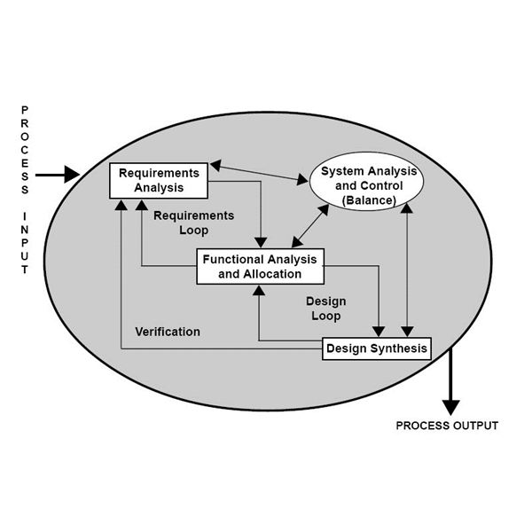

Figure 1 Functional analysis

## Non-Functional Requirements

A Non-functional requirements are those that specify how the system performs a certain function like how the system should behave and what limits are on its functionality. It determine the quality of the system. The non-functionality requirement explains a performance features of the system.

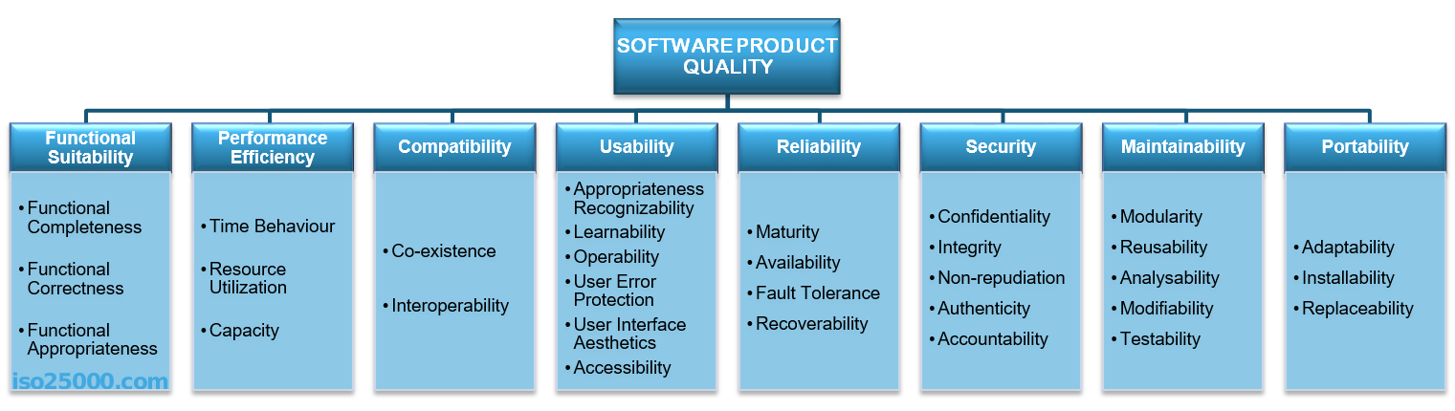

Figure 2 Non-functional Requirement

The above are the list of Non-functional requirement with some details and why it is needed.

|  |  |  |  |
| --- | --- | --- | --- |
| **ID** | **Title** | **Description** | **Rational** |
| NF1 | Performance | System must be able to perform all required task without problem. | Best performance system make it easier and faster to user |
| NF2 | Security | System must be secured to protect user and system | Secure system help to store information and protect system |
| NF3 | User Friendly | System need to be easy to understand so any user can used the system | To make the system easier to use and learn |
| NF4 | Reliable/ Data Integrity | System reliable is essential to the system as it helps user get accurate information | To provide information correctly so user are able to trust the system |
| NF5 | Efficiency | System need to be efficient as it allows user to use the system without other problem | To run system smoothly without any major problems like bugs, glitch etc. |
| NF6 | Capacity/  Scalability | System should have capacity or  Scalability for storage purpose | To have ability to store large amount of data and allows multiple user at same time |
| NF7 | Maintainability | System should be maintained regularly | To prevent errors and remove bugs system should be maintained |
| NF8 | Availability | Availability means information been available when needed | To provide information available to every user |
| NF9 | Environmental | System should not harm nature or environment | To make system eco- friendly |
| NF10 | Recoverability | Recoverability is like a data backup | To be able to recover and regained past data |

## MoSCoW Prioritization

A MoSCoW prioritization is a technique for managing requirement. It have four different categories that are: **must-haves, should-have, could-have** and **will not have at this time or Wise.** Here are the list of functional requirement with the help of MoSCoW method

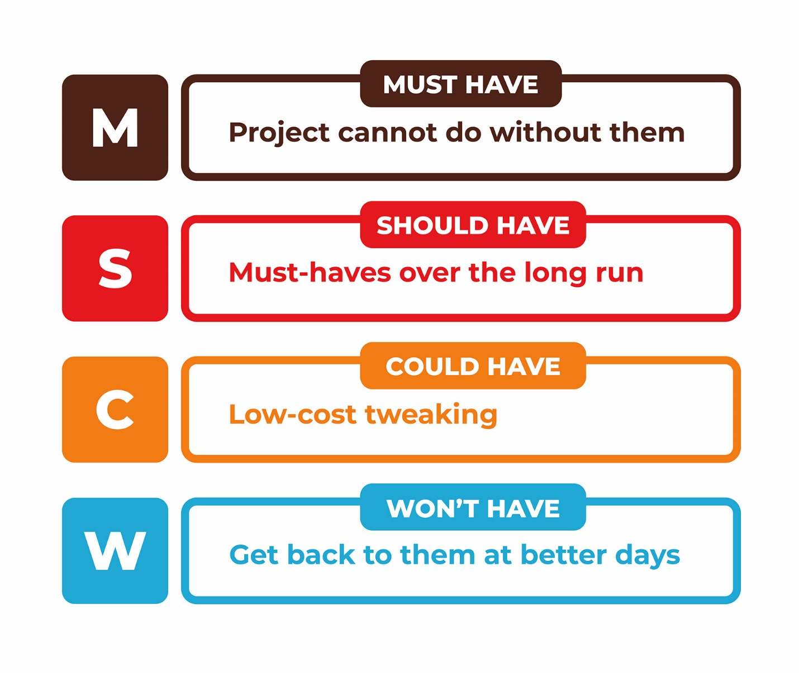

Figure 3 MoSCoW Prioritization

MoSCoW prioritization method is one of the simple method for requirement prioritization as being simple makes it quick and easy to complete. It can really help to rank and categorize the requirement to get effective product that can be more sufficient.

* **Functional Requirement**

The table below is for prioritization of the given functional requirement of my project.

|  |  |  |
| --- | --- | --- |
| **ID** | **Functional Requirement** | **MoSCoW Priority** |
| FR1 | User Registration | Must have |
| FR2 | User Login | Must have |
| FR3 | User Edit/ Delete Profile | Should have |
| FR4 | Admin Login | Must have |
| FR5 | Add New League | Must have |
| FR6 | Add New Team | Must have |
| FR7 | Add Player or Coach | Must have |
| FR8 | Edit League, Team, Player and Coach | Should have |
| FR9 | View League or Team Details | Must have |
| FR10 | View Player and Coach Details | Must have |
| FR11 | Create Record | Must have |
| FR12 | Edit or Delete Record | Must have |
| FR13 | View Record | Must have |
| FR14 | Add News and Updates | Could have |
| FR15 | View News and Updates | Must have |
| FR16 | Create Fixture | Must Have |
| FR17 | Manage Fixture | Should Have |
| FR18 | View Fixture | Must Have |
| FR19 | Update result At real time | Will not have or Wise have |

* **Non-functional requirement**

Here is the non-functional requirement with MoSCoW to help prioritize the requirement

|  |  |  |
| --- | --- | --- |
| **ID** | **Non-Functional Requirement** | **MoSCoW Priority** |
| NF1 | Performance | Must have |
| NF2 | Security | Must have |
| NF3 | User Friendly | Must have |
| NF4 | Reliable/Data Integrity | Must have |
| NF5 | Efficiency | Should have |
| NF6 | Capacity /Scalability | Should have |
| NF7 | Maintainability | Should have |
| NF8 | Availability | Must have |
| NF9 | Environmental | Must have |
| NF10 | Recoverability | Should have |

From the above table on both Functional and Nonfunctional requirement we got the priority. All Priority is explain as follows:

* **Must have**: Must have requirement are those which are non-negotiable. Without this the system cannot be run as it was supposed to. We cannot afford to leave out any as all is importance
* **Should have**: Should have requirement are those which is importance for the system but are not vital. May be painful to leave out but the system still runs
* **Could have**: Could have requirement are those which are wanted or desirable but are not really not that importance. It has less impact if left out.
* **Won’t have this time**: won’t have requirement are which are not really required to the system for at this time so it doesn’t affect the system if left out.

## System Requirement Specification

A system requirement specification (SRS) provide a detailed explanation of the features and behavior of the system. It gives knowledge about different hardware and software that are needed for developing the project. Here are the list of hardware and software requirement for completing my project they are as follows:

* **Hardware and Software**
* **Laptop with following specification**:

Windows 8, 8.1, 10 operating system with processor

Processor - dual core 2.4 GHz+ (i5 or i7 series Intel processor or equivalent AMD)

RAM - 4 GB and higher

Hard Drive - 256 GB or larger solid state hard drive

Graphics Card - any with DisplayPort/HDMI or DVI support - desktop only

Wireless (for laptops) - 802.11ac (WPA2 support required)

Backup Device - External hard drive and/or USB Flash Drive

* **Laptop with following application install:**

XAMPP: Cross-platform (X), Apache (A), MySQL (M), PHP (P) and Perl (P)

Star UML

Project Libre

Microsoft Office

Google Chrome, Mozilla Firefox etc.

# Use case

A use case diagram is a graphical representation of the interaction among the fundamentals of a system. (Margaret Rouse, 2015) It is used in system analysis so it can help to categorize, simplify and organize the system requirement.

The purposes of use case diagram are as follows:

* To use to gather the requirements of a system or project
* To get an external opinion of a system or project
* To recognize the external and internal factors influencing the system or project
* To show the interaction between the requirements are actors.

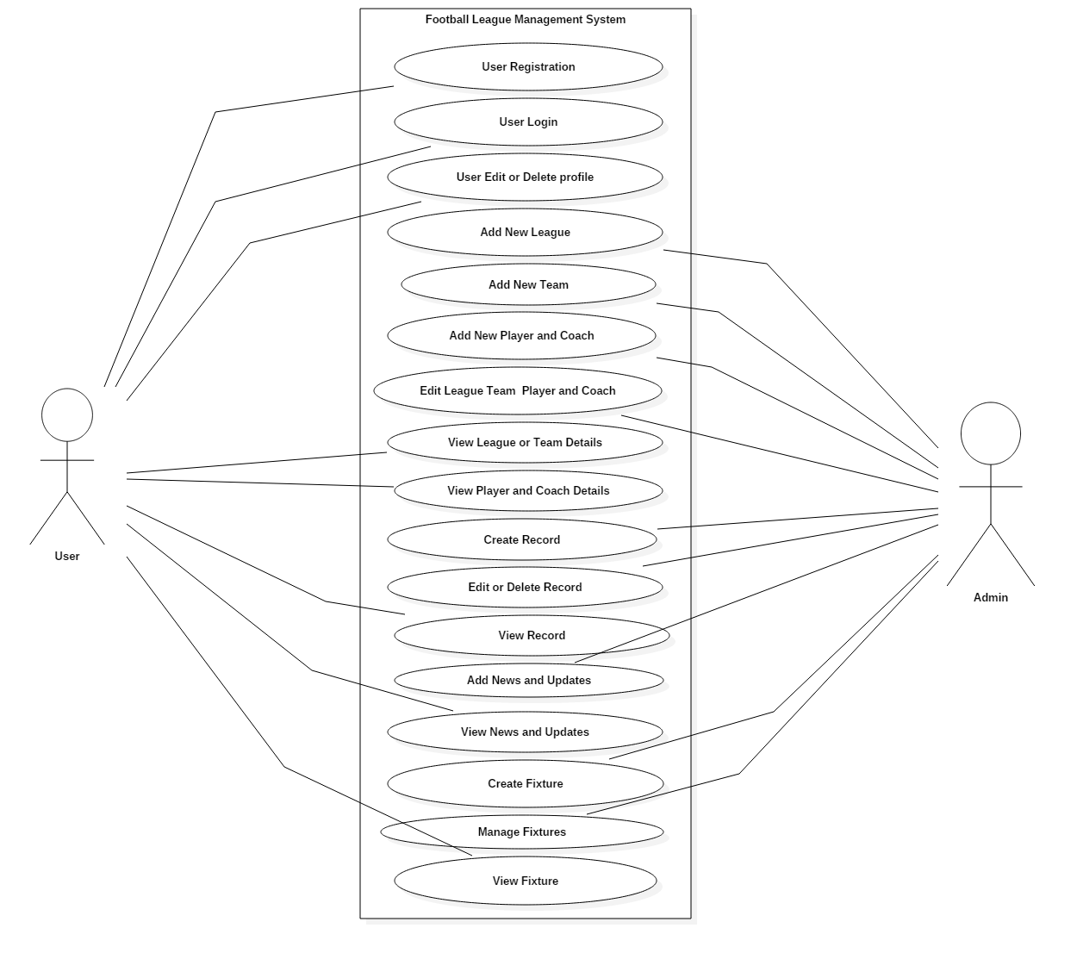

Figure 4 Use Case Diagram

|  |  |  |
| --- | --- | --- |
| **ID** | **Title** | **Description** |
| 1 | User Registration | For registering user with user details for creating profile and login |
| 2 | User Login | To access profile and system and more contents |
| 3 | User edit or delete profile | For Updating or deleting profile |
| 4 | Add New league | To be able to add new League to the system |
| 5 | Add New Team | To be able to add new teams to the league |
| 6 | Add New Player and Coach | To be able to add players and coach to the teams |
| 7 | Edit league, team, player or coach | To be able to edit or remove details |
| 8 | View League or Team Details | To be able to view details about league or team. |
| 9 | View Player and Coach details | To be able to view details about Player or Coach. |
| 10 | Create Record | To Create record related to wins, loss and ties. |
| 11 | Edit or Delete Record | To be able to edit, alter or remove details on record |
| 12 | View Record | User are able to view stats/record of their teams |
| 13 | Add News and Updates | To be able to provide information to the user about injury, transfer etc. |
| 14 | View News and Updates | User can view the information provided on News section about what happening on football worlds |
| 15 | Create Fixture | To be able to create matches between teams |
| 16 | Manage Fixture | Manage matches, alter and delete |
| 17 | View Fixture | User able to view details of matches between different teams |

# 

# Initial Class Diagram (NLA)

Class Diagram is a type of static structure diagram that helps to explain the structure of the system by showing the system’s class, their attributes, operation or method and relationship among object. (Visual Paradigm, 2015). NLA stands for Natural Language Analysis which is the process that helps to identify verbs, Adjectives and nouns where verbs are related to potential functionality that must be represented Adjectives that are related to potential attributes and Noun are related to potential classes.

Here is the scenario for my project to perform Natural Language Analysis. With the help of the following scenario

**Scenario**

Sometimes **user** are unable to get **information** about their **favorite** **teams**, **player** or even the **league** in related to their domestic **league** and international **teams**.

**Football** **League** is an **association** of **football** **clubs** that helps to organizes **matches** between different **teams** of a similar standard. **Football** **league** management **system** help to manage the **football** **leagues** and provides **user** to gains access on many different information about their favorite **teams**, **players** and **leagues**. It also helps to provide **stats**, **fixture** between **teams** in different **matches** and their **match’s** details.

Being the most famous **sports** on the world means having more no of fans who want to get **information**. There are many sites to get **information** but not every **user** get satisfied result of what they wants. The system helps **user** to accessed information and interact with the system. **User** are able to register which the **user** will be required to enter following information

1. **Name**
2. **Email Address**
3. **Location**
4. **Password**
5. **Gender**
6. **Phone Number**

Each register **user** will be able to interact with **system** to get **information**, **comment**, ask **question** etc. When **user** able to access the **system**. **User** need to create their own account to log into the system so they are allowed to:

* Access their registration
* Update their information
* Change their password

Football league Management System provides following functionality:

* Allows **user** to register themselves and edit the profile
* Allows **system** to create new **league**, **team**, **player** and **staff**.
* Allows **system** to alter change **League**, **Team**, **Player** and **Staff** information
* Allows **user** to view **league**, **team**, **player** and **staff** information
* Allows **system** to create and alter **Stats** **tables** and **Fixture**
* Allow **user** to add and alter **News** and **Updates**
* Allows **user** to **View** **Stats** **tables**, **Fixture**, **News** and **Updates**.

The **system** to manage **football leagues** will help user to accessed information and interact with **system** throughout any place of the world.

1. **NLA Table**

* **Noun**

List of noun after removing all repeating and synonym Noun from the scenario are as followed:

User, Information, Favorite, Teams, Player, League, Football, Stats, Fixture

Sport, Name, Email Address, Location, Password, Gender, Phone Number, System

Comment, Question, News and Updates, View

* **Verbs**

List of Verbs after removing all repeating and synonym Verbs from the scenario are as

Followed:

Organize, Manage, Access, Register, Provide, Update, Alter, Add, Interact

* **Adjectives**

List of adjectives after removing all repeating and synonym adjectives from the scenario are as Followed

Domestic, International, Different, Satisfied, Required, New

After Performing NLA these are the following Result

|  |  |  |
| --- | --- | --- |
| **Noun** | **Adjectives** | **Verbs** |
| User, Team, Player, League, Stats, Fixture, | New, Required, International, Domestic, | Access, Register, Update, Alter, Add |

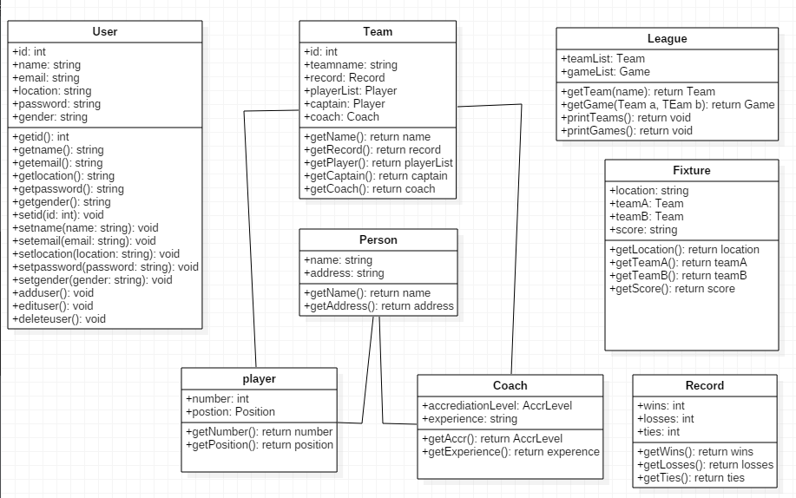

Figure 5 Initial Class Diagram

# References

* [Online]

(Nishadha Silva, 2016), “PEST Analysis”, URL: <https://www.business2community.com/strategy/pest-analysis-can-help-strategic-planning-01420731> Accessed on: 22nd April 2019

* [Online]

(Business Change Academy, 2017), “CATWOE”, URL: <https://businesschange.co.za/what-is-catwoe-analysis/> Accessed on: 24th April 2019

* [Online]

(Fraser Sherman, 2019), “Ethical Analysis”, URL: <https://bizfluent.com/how-7795257-conduct-ethical-analysis.html> Accessed on: 24th April 2019

* [Online]

(Margaret Rouse, 2015), “Use case Diagram”, URL: <https://whatis.techtarget.com/definition/use-case-diagram> Accessed on: 24th April 2019

* [Online]

(Visual Paradigm, 2015), “Class Diagram” URL:<https://www.visual-paradigm.com/guide/uml-unified-modeling-language/what-is-class-diagram/> Accessed on: 2nd April 2019